**Program to implement word count using Pig.**

First splits line into words using the TOKENIZE operator. The tokenize function creates a bag of words.



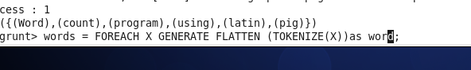

Using the FLATTEN function, the bag is converted into a tuple.

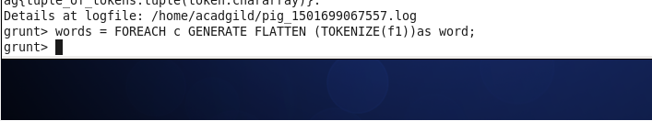

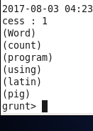

The words are grouped together so that the count can be computed

